CONDOR

Mechanical Key Cutting Machine

XC-009

User Manual

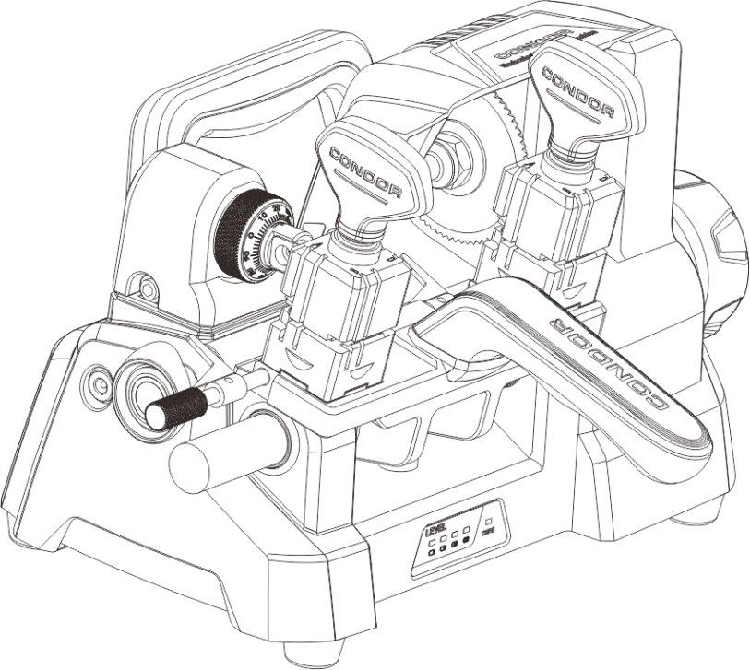



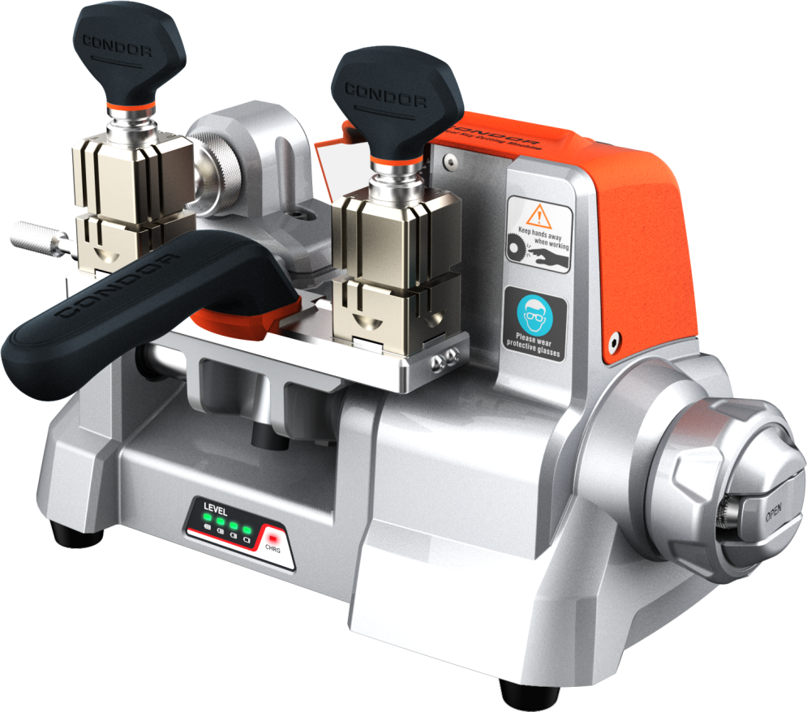

XC-009

Mechanical Key Cutting Machine

CONTENTS

1 Safety Precautions 5

2 General Information 6

2.1 Machine Description 6

2.2 Characteristics 6

3 Product Packaging Checklist 7

4 Overview 10

4.1 Schematic 10

4.2 Specifications 11

4.3 Main Parts and Function Declaration 13

4.3.1 Hand Wheel 13

4.3.2 Skid Platform 14

4.3.3 Micro-adjust slide 15

4.3.4 Clamp 16

4.3.5 Power Parts 17

5 Equipment Installing and Debugging 18

5.1 Handle Installing 18

5.2 Cutter Installing 19

5.3 Micro-adjust Slide Calibration 20

5.3.1 Lateral Micro-adjust Slide Calibration 21

5.3.2 Longitudinal Micro-adjust Slide Calibration 22

5.4 Clamp Installing 23

6 Use of Equipment 24

6.1 Key Alignment 24

6.1.1 Head spacing 24

6.1.2 Shoulder spacing 25

6.2 Clamp cutting surface selection 26

6.3Use of needle 27

7 Maintenance 28

8 Quality assurance and after-sales instructions 28

9 Appendix 30

# 1 Safety Precautions

To prevent personal injure or machine damage, users should carefully observe the instructions provided by this operation manual and adopt the following safety precautions:

* Use the machine under the safe condition
* Place the machine on a horizontal surface, which should be firm enough to carry the weight of the machine.
* Do not exposure machine in scorching sun or place the machine in any wet, oily, dusty area.
* Keep the machine clean and dry and keep a distance of 30cm from the wall for ventilation.
* Wear safety glass that meets ANSI standards.
* When the machine is working, keep clothing, hair, etc. away from all moving parts.
* Do not leave the machine while it is operating.
* Do not place anything on the machine while it is operating.
* Power plug with ground wire must be connected when charging. Do not use power plug that is out of power and loose.
* Turn off the switch when the machine is not in use or in service.
* Shut down the machine immediately when any exception occurs. The switch on the left side of the machine.
* Keep the machine out of reach of children.

# 2 General Information

## 2.1 Machine Description

Thank you for choosing CONDOR XC-009 Mechanical Key Cutting machine.

CONDOR XC-009 Mechanical Key Cutting machine is a portable special device specially designed for global locksmiths. It is small in volume, light in weight and easy to carry.

It can quickly and accurately copy and process variety of automobile and resident mechanical key types.

Please read it carefully before use. It is crucially important if you wish to operate the machine safely and efficiently.

## 2.2 Characteristics

CONDOR XC-009 is a new generation of mechanical Key Cutting machine with the following characteristics:

* Beautifully designed, full of modernity and technology.
* Integrated Casting, Aluminum structure, Durable.
* Small volume, Light weight, Easy to carry
* Ergonomics designed, More comfortable, simple and convenient.
* Micro-adjusted guide for high-precision cutting requirements.
* Built-in lithium battery, Super long endurance ability

# 3 Product Packaging Checklist

| Name | Image | Quantity | Description |
| --- | --- | --- | --- |
| Main Body | D:\JOAN\CONDOR XC-003卧铣机\XC-009\XC-009说明书 源文件\20180312(橙色）.145(1).png | 1 | Key Machine body |
| Handle | 捕获.PNG | 1 | Control handle, accessory processing |
| M6 screw |  | 2 | Fixed handle |
| Tools |  | 1 | Tools placed |
| Key spacer |  | 2 | stopper |
| 2.5mm Allen wrench | 内六角扳手2.5.png | 1 | Tool for removing |
| 3mm Allen wrench | 内六角扳手2.5.png | 1 | Tool for removing |
| 4mm Allen wrench | 内六角扳手2.5.png | 1 | Tool for trimming slide |
| 5mm Allen wrench | 内六角扳手2.5.png | 1 | Tool for trimming slide |
| Tool change rod | 换刀圆棒.png | 1 | Change the cutter |
| 19mm open spanner |  | 1 | Change the cutter |
| file | {13B90E1D-8DE3-4D00-9452-A3DA389C08E6}.png | 1 | Tool for polish |
| φ1.2mm nozzle cleaner |  | 2 | Tool for putting the key |
| φ1.7mm nozzle cleaner |  | 2 | Tool for putting the key |
| Power Adapter |  | 1 | Charger Device |
| Battery（Optional） |  | 1 | Power Device |
| Power cord（1.5m）  （optional） |  | 1 | Connect to power  (Chinese Standard) |
| Power cord（1.5m）  （optional） |  | 1 | Connect to power  (British Standard) |
| Power cord（1.5m）  （optional） |  | 1 | Connect to power  (European Standard) |
| Power cord（1.5m）  （optional） |  | 1 | Connect to power  (American Standard) |
| Brush | \\10.0.3.203\tmp$\暂用\产品图片\XC-mini\XCMN14CH.png | 1 | Tool for cleaning |
| Quality certificate and Product Packaging Checklist | D:\JOAN\CONDOR XC-003卧铣机\XC-009\XC-009说明书 源文件\XC-002合格证.jpg | 1 | Product delivery inspection certificate and packing statistics |
| User Manual(Take photo) | D:\JOAN\CONDOR XC-003卧铣机\XC-009\XC-009说明书 源文件\封面.jpg | 1 | Key machine installation and operation instructions |

# 4 Overview

## 4.1 Schematic

LED light

Handle

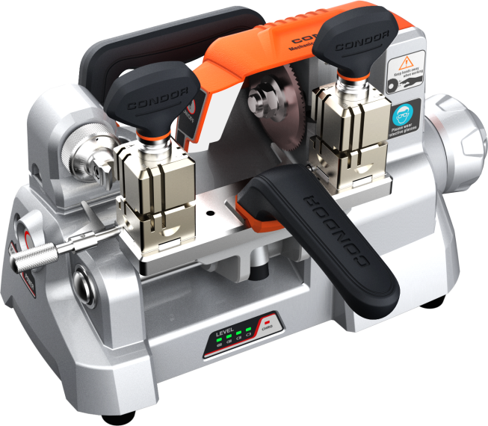

Micro-adjust slide

Shoulder space rod

Power jack

孔KONG1KONG1 KONG 孔

Hand wheel

Power display

Power switch

Main clamp

Cutter

Handrail

LED switch

Accessory clamp clamp

## 4.2 Specifications

|  |  |
| --- | --- |
| Input Voltage | 90-264V AC |
| Input Frequency | 47-63Hz |
| Consume | 110W |
| Power Parameter | 12-18V DC /3A |
| Battery Capacity | 2600mAh/22.2V |
| Spindle Speed | 900rpm |
| Motor Torque | 1.2Nm |
| Clamp Spacing | 95mm |
| Table Travel | 46mm |
| Working Temperature | 0-50℃ |
| Humidity | 10-90% |
| Net Weight | 10.8kg |
| Gross Weight | 12.5kg |
| Machine Dimensions | 285mm*175mm*200mm |
| Packing Dimensions | 420mm*310mm*300mm |

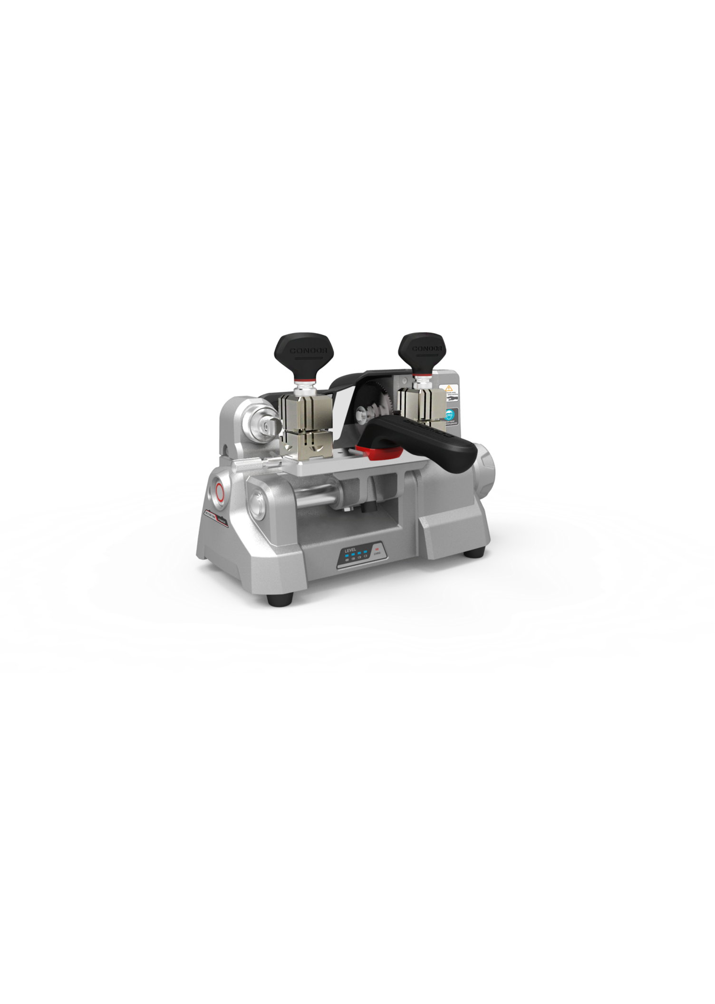

200mm

175mm

285mm

Machine Dimensions

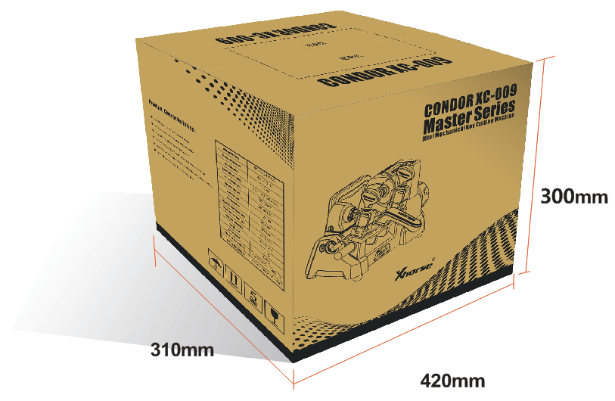

Packing Dimensions

## 4.3 Main Parts and Function Declaration

### 4.3.1 Hand Wheel

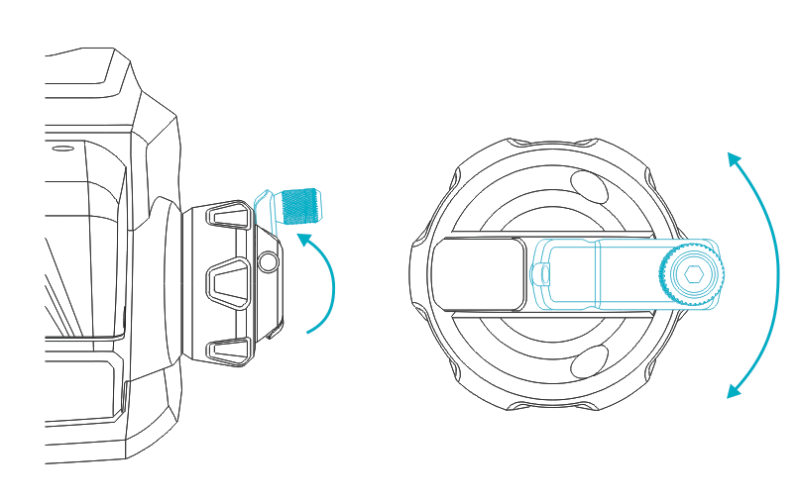

Unscrew the small hand wheel and turn the small hand wheel to achieve cutting feed. By rotating the hand wheel, the clamp slide can be controlled to move left and right, so as to achieve lateral feed during the cutting of the key. The hand wheel adopts a concealed structure, which opens outward when in use and can be hidden after use.

### 4.3.2 Skid Platform

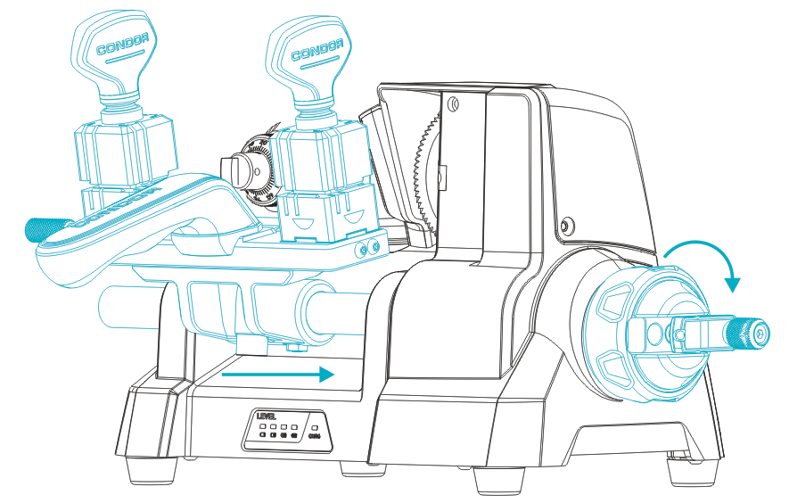

The clamp Skid Platform can be rotated about the axis of rotation and moved axially to achieve lateral and longitudinal feed of the key. Rotating the hand wheel to realize the lateral feed of the s Skid Platform, holding the handrail and rotating around the axis to realize the key longitudinal feed, the Skid Platform has a lateral stroke of 46mm and the clamp spacing is 95mm.

### 4.3.3 Micro-adjust slide

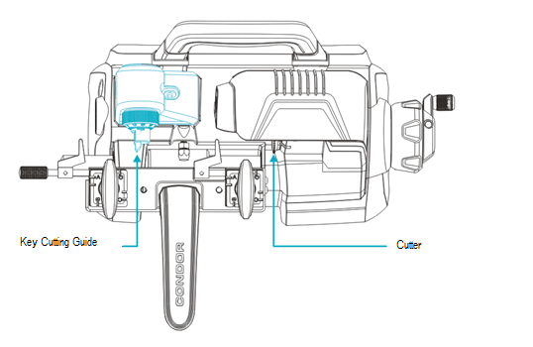

Adjust the Micro-adjust slide to align the cutter with key cutting guide.

### 4.3.4 Clamp

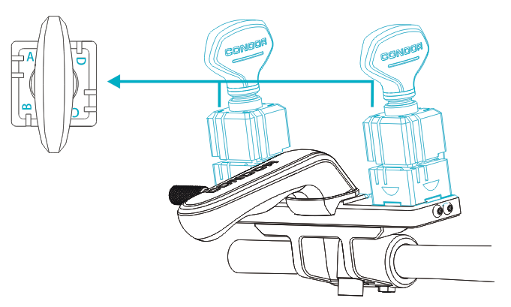

Allocation and clamp the key, the four-side (A、B、C、D)can be used to copy different key types. The left side is accessory clamp, placed original key, the right side is main clamp, placed blank key. Ensure that left and right clamp use the same cutting surface. Select the proper cutting surface according to different types (refer to chapter 6.2 clamp cutting surface selection and chapter 9 appendix). Be sure to clamp the key before cutting.

### 4.3.5 Power Parts

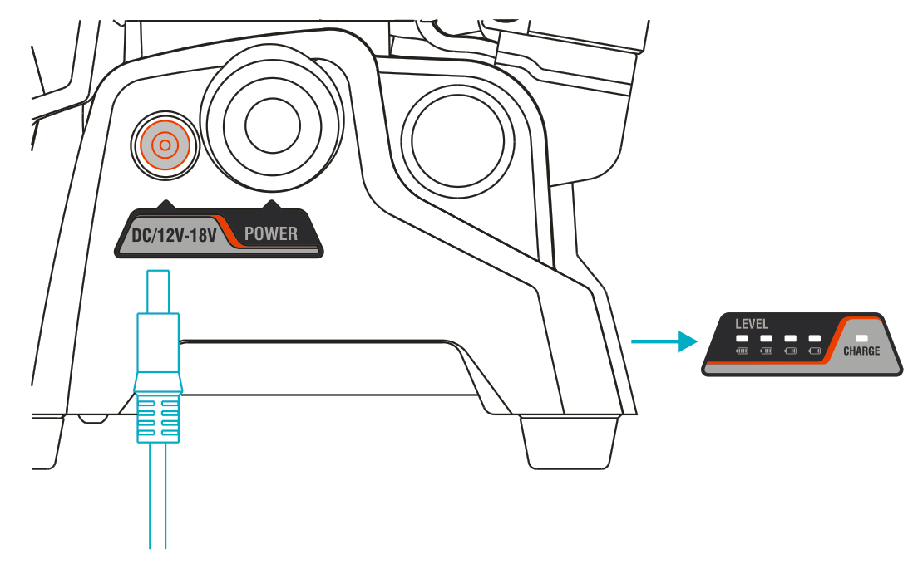

* There is a battery capacity indicator in front of the machine. When the power is low, the indicator is red. Please charge it in time. When power is fully, please unplug the power cord in time. It can be filled about 3-4 hours. After it is full, the machine can be cut the keys 60-100 continuously.
* Please use original power cord and adapter.
* Please use power socket with ground wire.
* Do not cut the key when charging.

# 5 Equipment Installing and Debugging

## 5.1 Handle Installing

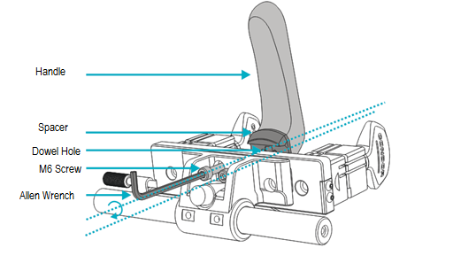

In order to save space, the handrail is separately from the whole machine in the package. Please open the box and install the handrail according to above picture.

## 5.2 Cutter Installing

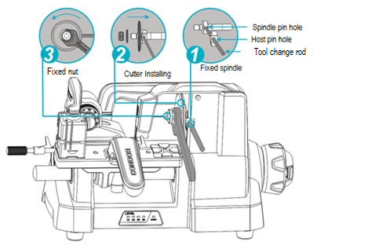

1. While the machine is stopped, slowly rotate the spindle, align the spindle pin hole with the host pin hole, and then insert the tool change rod into the end.
2. Installing the cutter on the spindle. Pay Attention to the front and back surface of cutter (with the word facing left), install the cutter block and lock nut (anti-nut).
3. Use the 19mm open spanner to tighten the lock screw counterclockwise. Then pull out the tool change rod. After installing the cutter, please refer to chapter 5.3 Fine Adjustment Slide Calibration.

## 5.3 Micro-adjust Slide Calibration

Micro-adjust slide calibration has been finished at the factory. If deviation or incorrect operations are found, please adjust it as follows.

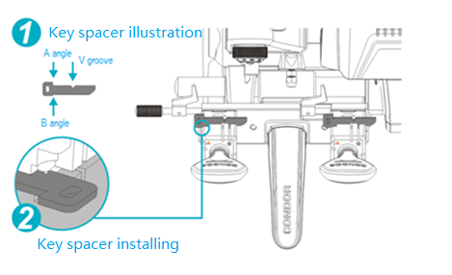

Firstly, both clamps are screw to A side, and clamp the Key spacer on both clamps. Closed the Key spacer to clamp, the clamp is tightened. And adjust the lateral and longitudinal adjustment of the slide separately.

### 5.3.1 Lateral Micro-adjust Slide Calibration

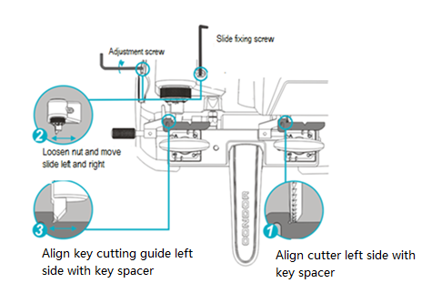

Perform lateral adjustment. After clamping the Key spacer, rotate and slide the clamp slide，the left side of cutter is close to the Key spacer, loosen the slide fixing screw slightly, and slowly adjust the left adjustment screw with an Allen wrench. The left side of the key cutting guide is just close to the Key spacer, and the fixing screw is tightened.

### 5.3.2 Longitudinal Micro-adjust Slide Calibration

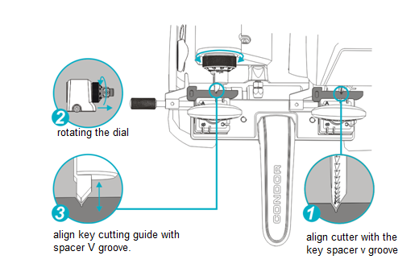

When the longitudinal direction adjusting, slowly rotates the clamp skid platform, align the cutter with the key holder v groove, then rotates the Micro-adjust slide dial, align the key cutting guide with the key holder v groove, rotates the dial 1 small lattice, the key cutting guide moves 0.02mm than before.

## 5.4 Clamp Installing

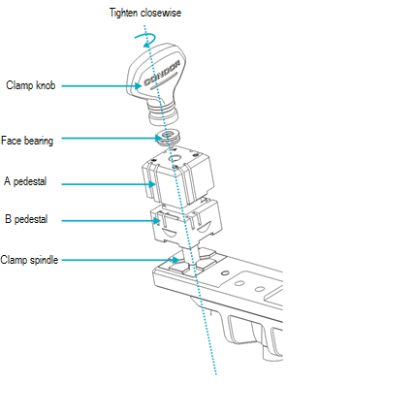

Do not remove the clamp under normal condition. If it is accidentally disassembled, please install according to the above figure. Pay attention to the clamp surface, otherwise it will not work normally.

# 6 Use of Equipment

## 6.1 Key Alignment

### 6.1.1 Head spacing

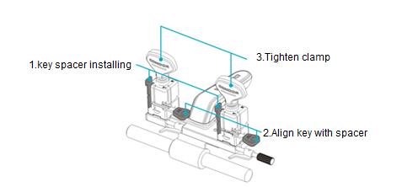

When the key head is spacing, use the alignment block, insert the positioning block into the spacing slot, slowly push the key until it touches the key spacer, the clamp is tightened to remove the key spacer.

### 6.1.2 Shoulder spacing

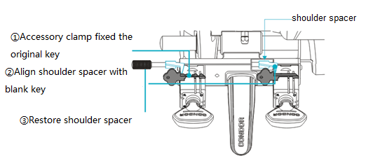

The original key is fixed on the accessory clamp, the shoulder spacer is aligned, then the blank key is aligned to the shoulder spacer, clamped, and finally the shoulder spacer is rotated to the initial state. 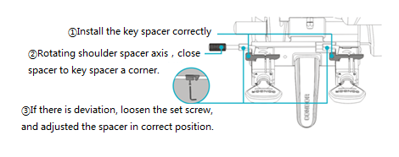

If it is found that the distance between the shoulder position and the fixture is inconsistent, it is necessary to calibrate the shoulder spacer. As shown in the following figure, installed the alignment block (refer to chapter 5.3), rotating the shoulder spacing axis, make the left and right shoulder spacer just close to the alignment block A angle, if there is deviation, release the set screw. Slowly move the shoulder spacer, and adjusted the spacer in correct position, then lock the set screw tightly. Remove the key spacer that it can be used normally.

## 6.2 Clamp cutting surface selection

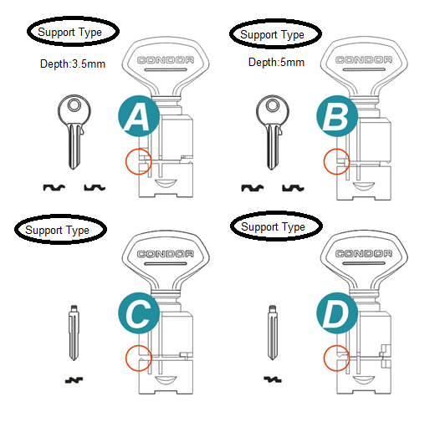

Clamp have A, B, C, D on all sides, different types of keys according to the above image to select the appropriate clamping surface, or reference appendix.

## 6.3Use of needle

When using A or B surface, the clamping depth too deep, cutting less than the complete , you can use the needle, change the clamping depth to ensure normal processing, as shown in the following figure：

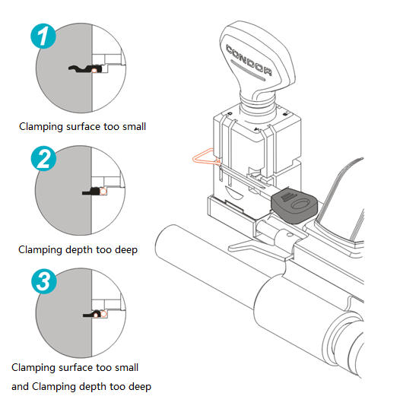

# 7 Maintenance

* Before cutting the key, please use the brush to clean up the debris of the parts of the processing area to avoid the impurity damage and corrosion the machine parts, affecting the key processing accuracy.
* Do not use any oily products and detergents to clean all parts of the machine to avoid damage or corrosion the machine parts.
* Do not wash machine and parts with water directly, do not wipe the machine with wet cloth, in case of leakage of machine or rust of metal parts
* In order to avoid the debris blown into the machine inside, causing safety problems， please do not use air guns, hair dryers and other cleaning equipment cleaning processing area.

# 8 Quality assurance and after-sales instructions

CONDOR XC-009 warranty period is one year, subject to the date on the transaction voucher, if no transaction voucher or transaction voucher is lost, the factory record date shall prevail.

The following conditions are not free warranty：

* Failure to use the instructions as required
* Machine damage caused by self repair or modification
* Machine failure due to drop, collision or improper voltage
* Machine damage caused by force majeure
* Used for a long time in harsh environments or on vehicles or ships, causing machine malfunctions or damage.
* The normal use of the machine causing the daily wear.

Product After-sale repair and technical support, please contact the dealer or use WeChat scanning QR code, attention to the official WeChat public accounts of the Xhorse (WeChat: SZ-Xhorse).



Xhorse league

Xhorse reserve all rights to this manual. No person or organization is allowed to copy and disseminate any part of this manual in any form without permission. Due to product improvement, the contents of this manual may be changed without prior notice。

# 9 Appendix

|  |  |  |  |  |
| --- | --- | --- | --- | --- |
| 名称 | 常见车型 | 钥匙特征 | 国内钥匙参考编号 | 钥匙外形图 |
| BYD56 | 比亚迪F3 | 外铣两轨迹12齿  头定 | 56号 |  |
| BYD66 | 比亚迪F0 | 外铣两轨迹6齿  头定 | 66号 |  |
| BT74 | 奔腾B50 | 外铣两轨迹8齿  肩定 | 74号 |  |
| B107 | 别克老君越 | 外铣两轨迹10齿  头定 | 87 号 |  |
| CY24 | 克莱斯勒 300C ，漫步者 切诺基 道奇 jeep | 外铣两轨迹8 齿  头定（7 齿） | 4 号 |  |
| DW04R | 别克凯越 乐风 乐驰 乐骋 赛欧 长安锐翔 江淮骏铃货车 | 外铣两轨迹8 齿  肩定 | 39 号 |  |
| DW05 | 景程 卡帕奇 | 外铣两轨迹8 齿  肩定 | 40 号 |  |
| FO38R | 福特水星 锐界 F150 翼虎 林肯 野马 | 外铣两轨迹8 齿  头定 | 19 号 |  |
| GM37 | 老GL18 老君威 陆尊 林荫大道 | 外铣两轨迹10 齿  头定 | 26 /101 号 |  |
| GT15 | 南京菲亚特 派力奥 周末风 老法拉利 | 外铣两轨迹9 齿  肩定 | 60 号 |  |
| HU49 | 捷达 桑塔纳 高尔夫 老奥迪100 红旗B4 246桑塔纳 256捷达 | 外铣两轨迹7 齿  肩定 | 1 号 |  |
| HU46 | 欧宝 安德拉 | 外铣两轨迹10 齿  肩定 |  |  |
| HU87R | 铃木雨燕 新奥拓 天语 吉姆尼 维特拉 | 外铣两轨迹10 齿  肩定 | 10 号 |  |
| HYN11 | 06-09起亚千里马 左、伊兰特 途胜 赛拉图 新瑞风 | 外铣两轨迹8 齿  肩定 | 28 号 |  |
| HYN7R | 现代索纳塔 名驭 华泰圣达菲 | 外铣两轨迹8 齿  肩定 | 29 号 |  |
| HY15 | 现代御翔 起亚K2 领翔 | 外铣两轨迹8 齿、  10 齿头定 | 33 号 |  |
| HY16  HY17 | 新现代悦动 福瑞迪 | 外铣两轨迹10 齿  头定 | 97 号 |  |
| MIT11R | 三菱 东南 北斗星 夏利 | 外铣两轨迹8 齿  肩定（10 齿） | 7 号 |  |
| MAZ24 | 马自达 3,5,6海马 东南福美来， | 外铣两轨迹10 齿  肩定 | 27 号 |  |
| MIT8 | 三菱大发克莱斯勒 | 外铣两轨迹8 齿  肩定 |  |  |
| NE38 | 澳洲本田福特MG MINI 尼桑路虎 | 外铣两轨迹10 齿  肩定（7、8、12 齿） | 15 号 |  |
| NE71R | 罗浮 | 外铣两轨迹10 齿  肩定 |  |  |
| NE72 | 标致206 207 C2 07 款毕加索 | 外铣两轨迹6 齿  肩定 | 53 号 |  |
| NSN11 | 老款尼桑巴宁风度蓝鸟公爵 | 外铣两轨迹8 齿  肩定 | 6 号 |  |
| NSN14 | 新款日产尼桑天籁骐达颐达  骊威智能卡小钥匙 | 外铣两轨迹10 齿  头定（11 齿） | 22 号 |  |
| QR51 | 奇瑞A3，A5 瑞虎东方之子 | 外铣两轨迹8 齿  肩定 | 51 号 |  |
| SX9 | 雪铁龙爱丽舍，毕加索，富康，吉利自由舰，上海华普十字坯 | 外铣两轨迹5 齿  头定 | 83 号 |  |
| TOY38R | 嘉华金杯夏利大宇 | 外铣两轨迹8 齿  肩定 | 8 号 |  |
| TOY43 | 丰田凯美瑞，丰田锐志卡罗拉 花冠，佳美，吉利金刚 | 外铣两轨迹10 齿  头定 | 2 号 |  |
| TOY43R | 新斯巴鲁XV 绚丽长城汽车M4、嘉誉 | 外铣两轨迹10 齿  头定 | 69 号 |  |
| YM28 | 欧宝 | 外铣两轨迹10 齿  肩定 |  |  |